Clark County Market Animal Project Summary for Sheep, Beef, Swine

Animal Category: (Check one) _______ Steer _______Lamb ______Swine

Name: Age: Grade:

Address: City:

Parent or Guardian:

4-H Club or FFA Chapter:

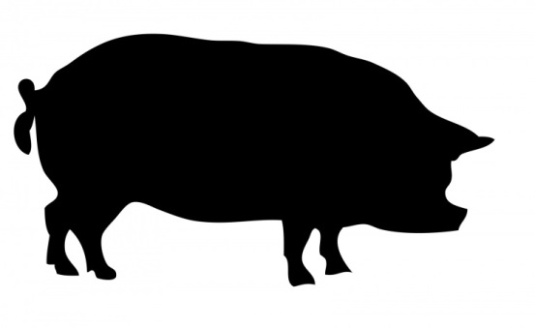

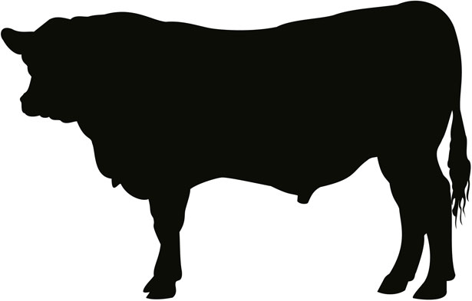

Clark County Market Animal Project Summary Record for Sheep, Beef, Swine
This Record is due the day of the
Livestock Sale Banquet

* All 4-H and FFA Youth are required to complete a Project Summary Record for the animal they are selling at the livestock sale. This completed form is due at the livestock sale banquet in order to receive one's livestock sale check.

1. Animal Category: (Check one) _______ Steer _______Lamb ______Swine
A. Number of years in the Market Animal category checked above:
B. Number of years participating in the Livestock Sale:

2. Date of Initial Weigh-In:

3. Initial Weigh In Weights (*place an Asterisk in front of the animal that was sold in the livestock sale):
A. Tag # Weight D. Tag # Weight
B. Tag # Weight E. Tag # Weight
C. Tag # Weight

4. Initial Value of Animal (Answer A or B - NOT BOTH)
A. If purchased - Actual Cost: $
B. If homebred - Assign a Cost: $ /LB x weigh in weight = $

(May use the current market price for a feeder animal the week of the weigh- in)

5. Housing (check one)
A. ______ My market animal is housed where I live.
B. ______ My market animal is housed at a place other than where I live.

Describe the agreement between you and the person housing your animal (e.g. How often do you go out to feed and work with the animal):

6. Please list the three educational opportunities you attended:
A.
B.
C.
7. Feed Expenses (additional space available on page 4)

Date Purchased | Type of Feed Purchased or Raised on Farm  (may use market prices to calculate feed costs raised on farm) | Cost
Jan
Feb
Mar
Apr
May
Jun
Jul
Aug
7A - TOTAL EXPENSES

8. Miscellaneous Expenses (veterinary, bedding, trucking, etc.)

Date | Type of Expense | Cost
8A - Total Miscellaneous Expenses

9. Total Costs of Raising Market Animal
A. Initial Cost (total from line 5A or 5B)
B. Feed Expenses (total from line 7A)
C. Miscellaneous Expenses (total from Line 8A)
D. Total Project Cost (add 9A, 9B, 9C) _____________

10. Final Weigh-In Weight: Date of Final Weigh-In:

11. Total Pounds Gained:
- =
Final Weight Initial Weight Total Pounds Gained

12. Number of Days on Feed (circle appropriate species; weigh in date to weigh in at fair)
________ Sheep ________ Beef ________ Swine

13. Average Daily Rate of Gain:
A. Total Pounds Gained (from line 11)
B. Number of Days on Feed (from line 12)
C. Daily Rate of Gain (divide 13A by 13B)

14. Net Returns (Actual Profit or Loss)
A. Net return through the Clark County livestock sale
a. Final Weigh-In Weight (from line 10) lbs.
b. Price per pound received at Clark County
Livestock Sale $
c. Total Income of Animal (multiply a x b)
d. Total Expenses (line 9D)
e. Sales deduction - 8% commission
(multiply 14Ac x 0.08)
f. Amount of PROFIT OR LOSS (circle one)
(subtract line 14Ad and 14Ae from 14Ac $

B. Net return at Current Market Price
a. Final Weigh-In Weight (from line 10) lbs.
b. Price per pound at current market price
the week of the livestock sale (Market Price Per Pound)
c. Total Income of Animal (multiply a x b)
d. Total Expenses (line 9D)
e. Amount of PROFIT OR LOSS (circle one)
(subtract line 14Bd from 14Bc) $

15. Events, shows, judging, demonstrations, project meeting, and dates you worked with animal, etc.
Please list what you have done in the project this year.
Date | Describe event

16. Please share what you have learned in the project this year.

17. For those youth 15 and older – how have you shared your knowledge with younger members of your organization?

