Clark County Market Animal Project Summary for Beef, Goat, Sheep, & Swine

Animal Category: (check one) Beef Goat Sheep Swine

Name: Age: Grade:

Address: City:

Parent or Guardian:

4-H Club or FFA Chapter:

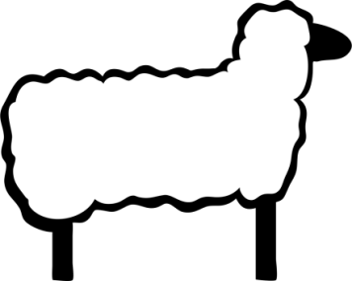
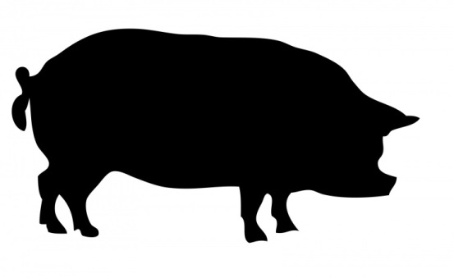
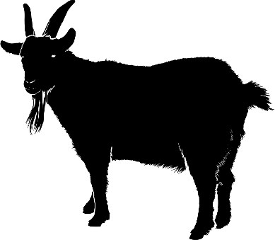

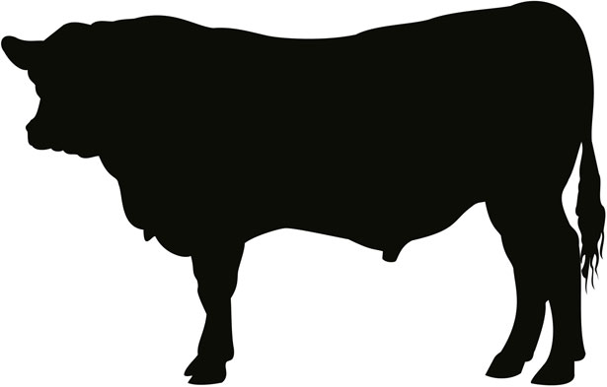

Revised: 3/24
Clark County Market Animal Project Summary Record for Beef, Goat, Sheep, & Swine
This record is due the day of the
Livestock Sale Banquet

*All 4-H and FFA Youth are required to complete a Project Summary Record for ONLY the animal they sold at the livestock sale. This completed form is due at the livestock sale banquet in order to receive one's livestock sale check.

1. Animal Category: (check one) Beef Goat Sheep Swine
A. Number of years in the Market Animal category checked above:
B. Number of years participating in the Livestock Sale:

2. Initial Value of only the 1 animal sold (Answer A or B - NOT BOTH)
A. If purchased - Actual Cost: $
B. If homebred - Assign a Cost: $ /LB x weigh in weight = $
(May use the current market price for a feeder animal the week of the weigh-in)

3. Date of Initial Weigh-In:

4. Initial Weigh-In Weights (include all animals weighed in - *place an asterisk in front of the animal that was sold in the livestock sale):
A. Tag # Weight D. Tag # Weight
B. Tag # Weight E. Tag # Weight
C. Tag # Weight

5. Final Weigh-In Weight: Date of Final Weigh-In:

6. Total Pounds Gained:
- =
Final Weight Initial Weight Total Pounds Gained

7. Number of Days on Feed (number of days from weigh-in date to weigh-in at fair)
Beef Goat Sheep Swine

8. Average Daily Rate of Gain:
A. Total Pounds Gained (from line 6)
B. Number of Days on Feed (from line 7)
C. Daily Rate of Gain (divide 8A by 8B)

9. Feed Expenses
Date | Type of Feed Purchased or Raised on Farm  (may use market prices to calculate feed costs raised on farm) | Cost
Jan
Feb
Mar
Apr
May
Jun
Jul
Aug
9 - Total Feed Expenses

10. Miscellaneous Expenses (veterinary, bedding, trucking, etc.)
Date | Type of Expense | Cost
10 - Total Miscellaneous Expenses

11. Total Costs of Raising Market Animal
A. Initial Cost (total from line 2A or 2B)
B. Feed Expenses (total from 9)
C. Miscellaneous Expenses (total 10)
D. Total Project Cost (add 11A, 11B, and 11C) _____________

12. Net Returns (Actual Profit or Loss)
A. Net return through the Clark County livestock sale
a. Final Weigh-In Weight (from line 5) lbs.
b. Price per pound received at Clark County
Livestock Sale $
c. Total Income of Animal (multiply a x b)

d. Total Expenses (line 11D)
e. Sales deduction - 8% commission
(multiply 12Ac x 0.08)
f. Amount of PROFIT OR LOSS (circle one)
(subtract line 12Ad and 12Ae from 12Ac) $

B. Net return at Current Market Price
a. Final Weigh-In Weight (from line 5) lbs.
b. Price per pound at current market price
the week of the livestock sale (not fair sale) (Market Price Per Pound)
c. Total Income of Animal (multiply a x b)
d. Total Expenses (line 11D)
e. Amount of PROFIT OR LOSS (circle one)
(subtract line 12Bd from 12Bc) $

13. Housing (check one): [ ] Animal kept at home [ ] Animal kept elsewhere

14. What did you do to make sure your animal is being taken care of (who feeds it, how often, etc):

15. Please list the three educational opportunities you attended:
A.
B.
C. _______________________________________________________________________________

16. List events, shows, judging, demonstrations, project meeting, and dates you worked with animal, etc.
Date | Describe Event

17. Please share what you have learned in the project this year.

18. For those youth 15 and older – how have you shared your knowledge with younger members of your organization?

