**Green Thumb Challenge 2025**

**Rules and Guidelines**

1. Open to all Clark County 4-H clubs.
2. The planter container should be a large animal mineral bin/barrel.  
   Common colors are black and blue.  
   Drill holes in the bottom for proper drainage.
3. Put your club name somewhere on the planter in a visible location.
4. Plants should be started and maintained through growing season.
5. Please identify the plants you have placed in your planter.
6. Plants should be seasonal and grown in the planter.
7. Planters should be in place by 8:00 p.m. on Wednesday.
8. Identify individuals who participated in creating the planter.

**All participating 4-H clubs will receive $25 for their planter courtesy of the   
Clark County 4-H Leaders Federation.**

**Green Thumb Challenge Entry Form**

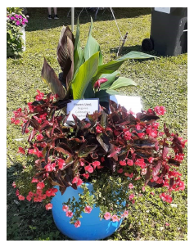

Club Name

Contact Person

Phone Number

Email Address

(for fairgrounds planter location map)

**During the Clark County Fair your club members will be responsible for   
the care and maintenance of your planter.**

Send entry form to: [ClarkCounty4H@co.clark.wi.us](mailto:ClarkCounty4H@co.clark.wi.us)

Or mail to: Extension Clark County

Attn: Green Thumb Challenge

517 Court Street, Room 104

Neillsville, WI 54456

**REGISTRATIONS MUST BE RECEIVED BY JULY 1ST.**