***4-H Club Historian***

***C*ongratulations!**

Now that your club has elected you as the historian, you, and all other officers of your 4-H club are representatives. You represent not only the local club, but also the 4-H program throughout the state. Your skills and abilities, standards and ideals, grooming, speech and even smiles represent the 4-H program. Representing others is one of your most important responsibilities because it exists at all times-not just while you are at 4-H events.

**Tips for Being a Good Leader**

1. Be a team player
2. Be thoughtful of others
3. Be helpful
4. Be a good sport
5. Be reliable and responsible
6. Celebrate others' success
7. Be fair
8. Have fun with 4-H!!!

**Historian Job Description:**

1. Keep a record of the club's accomplishments and activities for the year.
2. Collect items such as pictures and news clippings about the club and its members.
3. Organize a scrapbook to tell the club's story for the year.
4. Make the scrapbook meaningful to members and future members.
5. Make the book compact but complete by including items only if they involve the club directly or members of the club.

**Guidelines for Historians**

1. The cover of the historian's book should be durable so it will last several years.
2. Pages need to be securely fastened in the book.
3. Items entered in the book should be in good condition and fastened securely.
4. The historian's book tells the story of the club for that year.
5. The historian's book should be accurate and neat.

The following is a list of items that would be helpful in telling your story. Be sure to include any additional items your club feels are important.

* 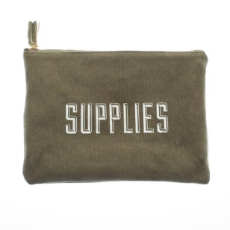Title page
  + Club name
  + Year
  + Historian's name(s)
* Group members, officers, leaders
* A photocopy of your club charter
* Clippings
* Pictures (well labeled, people, dates)
* Goal setting for club recognition form (if used)
* Certificates/Ribbons (only if a group award)
* Special correspondence
* Secretary's book
* Treasurer's book
* Story

**Practice for Historians…***Examples:*

*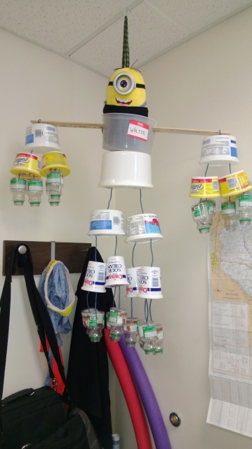A correctly labeled picture:*

**Walter is our cups, pints, quarts to gallons helper for our foods and nutrition classes; 2 cups go into a pint, 2 pints go into a quart, 2 quarts go into a gallon.**

*A paragraph describing family fun night:*

Family fun night was hosted on July 4, 20__, at the city park. Each member invited their family to a potluck meal followed by fun and games. We wanted our club families to feel connected to the club.

*Which of these would you include in the historian's book?*

1. A picture of your club's delegates to the state 4-H conference.
2. Tickets to your club's magician show.
3. An invitation to the county roller-skating party.
4. A news article listing county fair ribbon winners.
5. The program your group designed for the county fashion revue.
6. A thank you from the city for your group's work at the baseball field.
7. A napkin from your group's family fun night.

(Answers are on the last page.)

**Your Club's History**

It is important that current club members understand not *only* how 4-H came to be and how your club originated. The historian presents your club's history. You could even have a birthday party for your club in the month it was founded by presenting the history and having birthday cake. General information about 4-H is available from the state 4-H office or your extension agent.

Future generations of 4-H'ers will want to see what the club's former members participated in and how 4-H has changed. In order to make the historian's book interesting, you can use scrapbooking/card making techniques and materials found in your local craft store. The sample shows a picture of a club member and has a description of some important events from the county fair. Be sure to include last names when labeling pictures and use exact dates. If using digital pictures, be sure to print them on photo quality paper so they will stay clear longer. Store all the historian's books in a dark and dry area to avoid mold and yellowing of the pages.

*Sample historian's book page:*

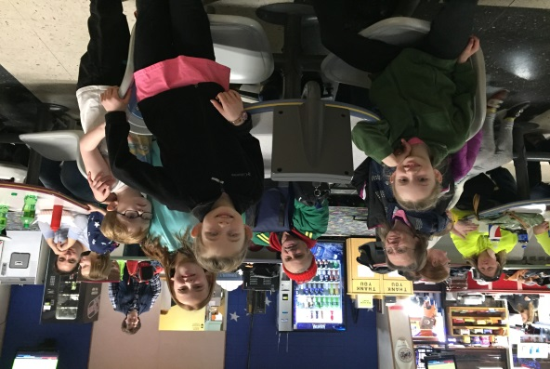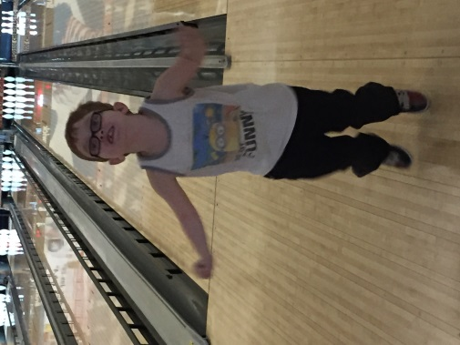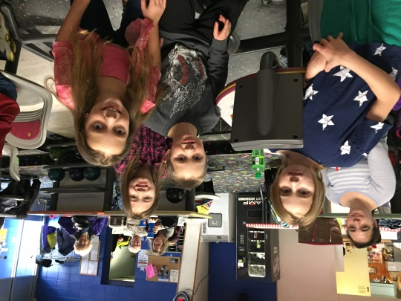 

Jim, Bobby, Alice, Suzy, Ester, Olivia, Marge, and Gladys Smith participated in bowling at the all-county 4-H bowling family day January 7, 2017

***Tips for finding club history:***

* Ask members' parents who grew up in the area or were members of the club.
* Go to the local museum. Most counties have at least one museum with local historical information.
* Check old high school yearbooks for information on charter members.
* Check out your Extension office, for any historical documents.

**PRACTICE**

Make a list of three activities your group participated in last year. Write a short paragraph about each for the historian's book.

Activity One: __________________________________

__________________________________________________________________________

__________________________________________________________________________

__________________________________________________________________________

__________________________________________________________________________

Activity Two: __________________________________

__________________________________________________________________________

__________________________________________________________________________

__________________________________________________________________________

__________________________________________________________________________

Activity Three: _________________________________

__________________________________________________________________________

__________________________________________________________________________

__________________________________________________________________________

__________________________________________________________________________

Create your own scrapbook page:



Answers from page 2 - Include these in your historian's book: a, d, e, f, you may include all the items listed, but be sure to include pictures and captions because a ticket or a napkin by itself does not tell a story.

This publication adapted from James P. Adams, *So You Are Historian of Your Club,* Kansas State University, June 2005 version by Christine Hollar Ed.D. 4-H Youth Development Educator in February 2017.

Contents of this publication may be freely reproduced for educational purposes. All other rights reserved. ln each case, credit James P. Adams, *So You Are Historian of Your Club,* Kansas State University, June 2005.